**ONE WAY ANOVA : WORKED EXAMPLE**

* Scores from three samples A,B and C
* Sample Mean and Standard Deviations given for each sample.
* Also given is the overall sample mean and standard deviation (for all 12 items)

|  |  |  |  |  |
| --- | --- | --- | --- | --- |
|  | **A** | **B** | **C** | **Total** |
|  | 15.08 | 22.58 | 10.67 |  |
|  | 13.58 | 19.33 | 13.42 |  |
|  | 12.33 | 22.42 | 13.92 |  |
|  | 12.08 | 22.92 | 10.67 |  |
| mean | 13.2675 | 21.8125 | 12.17 | 15.75 |
| std. deviation | 1.375 | 1.66808 | 1.744037 | 4.729759 |

Individually compute the following identities

* Total Sum of Squares (TSS)
* Between-Groups Sum of Squares (SSB)
* Within Groups Sums of Squares (SSW)

Confirm the following equation

***TSS = SSB + SSW***

Complete the ANOVA Table

|  |  |  |  |  |  |
| --- | --- | --- | --- | --- | --- |
| **Source** | **D.F.** | **S.S** | **MS** | **F** | **p-value** |
| Between Groups |  |  |  |  |  |
| Within  Groups |  |  |  |  |  |
| Total |  |  |  |  |  |

P-Values for Various Test Statistics

|  |  |
| --- | --- |
| Test Statistic | p-value |
| 11.65 | 3.18E-03 |
| 20.34 | 4.58E-04 |
| 35.98 | 5.09E-05 |
| 43.34 | 2.36E-05 |
| 48.92 | 1.46E-05 |

**One Way ANOVA - Worked Example**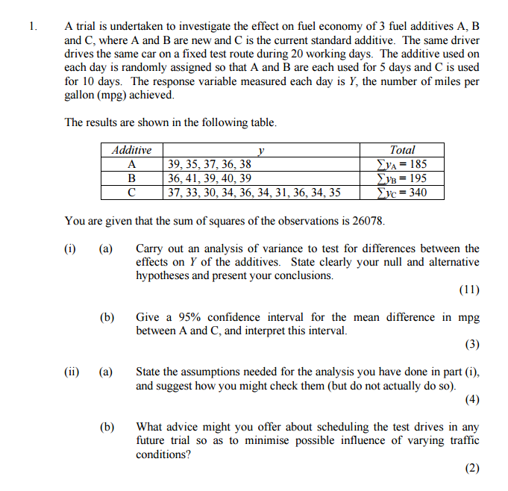

You are given the additional piece of information , sufficient to construct ANOVA table

|  |  |  |  |  |
| --- | --- | --- | --- | --- |
|  | **A** | **B** | **C** | **Total** |
| **mean** | **37** | **39** | **34** | **36** |
| **std. deviation** | **1.5811** | **1.8708** | **2.2111** | **2.8837** |

**Solution to One Way ANOVA Table**

* Additives: Between Groups
* Residuals : Within Groups

